OS 11000 - Introduction to Wilderness Skills - Fall 2019

Welcome! I am excited to be teaching Expedition Alaska’s Outdoor Studies OS11000 Introduction to Wilderness Skills. The course is an amazing immersion into Alaska wilderness, APU, and Outdoor Studies. Here are some details that will help you prepare for the course.
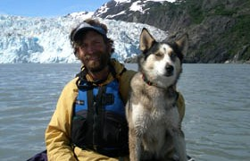

Sincerely,
Paul Twardock
Professor, Outdoor Studies
pault@alaskapacific.edu

OS 11000 is an introduction to the skills necessary for safe, efficient wilderness travel, including expedition planning, equipment, rations, camping, travel on both water and land, and hazard recognition. Students should expect to be in the field the majority of the class traveling in remote, off trail terrain.

The course is a section of Expedition Alaska aimed at Outdoor Studies students and others interested in extended wilderness travel.

OS11000 aims to introduce students to their peers, the academic competencies of APU, and Alaska. As the foundational Outdoor Studies field course OS11000 will develop the skills and competencies students need to be successful in all OS field courses.

This year the course will have three distinct sections.

Section 1: 8/26-30
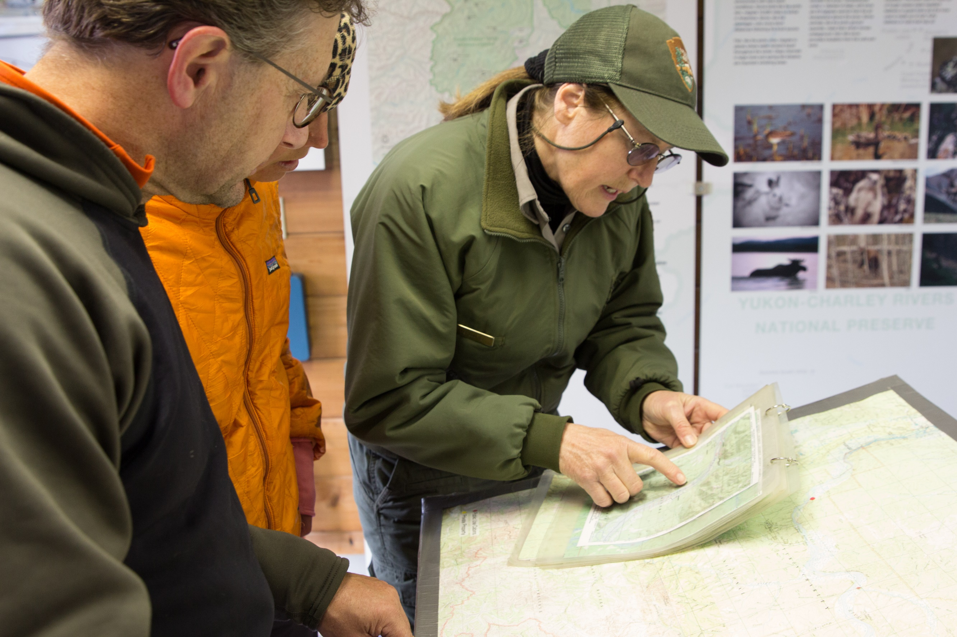

The first 5 days will be focused on preparing for the field section.

Students will be introduced to APU and OS’s competencies. Though we will be staying on the APU campus, the class meetings will occupy most if not all of each day.

Section 2: 9/1-9/11
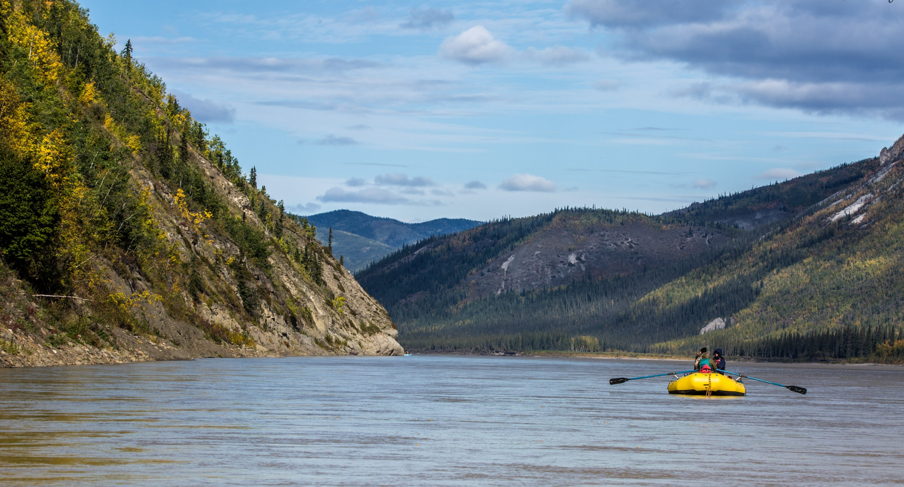
Once fully prepared, the course will travel along with other Expedition Alaska students to Eagle, Alaska. OS 11000 will then canoe down the Yukon to Circle, Alaska. The Yukon is an excellent river to learn the art and skill of canoeing. Expect temperatures ranging from 65 degrees to sub-freezing.

We will be camping in Yukon Charley National Preserve, a remote, seldom visited park, with little communication and no emergency services. Students should have basic swimming skills in case a canoe flips. Though the Yukon is considered class I, or calm, water, it moves at 10-15 mph and is one of the largest volume rivers in North America.

Section 3: 9/12-20
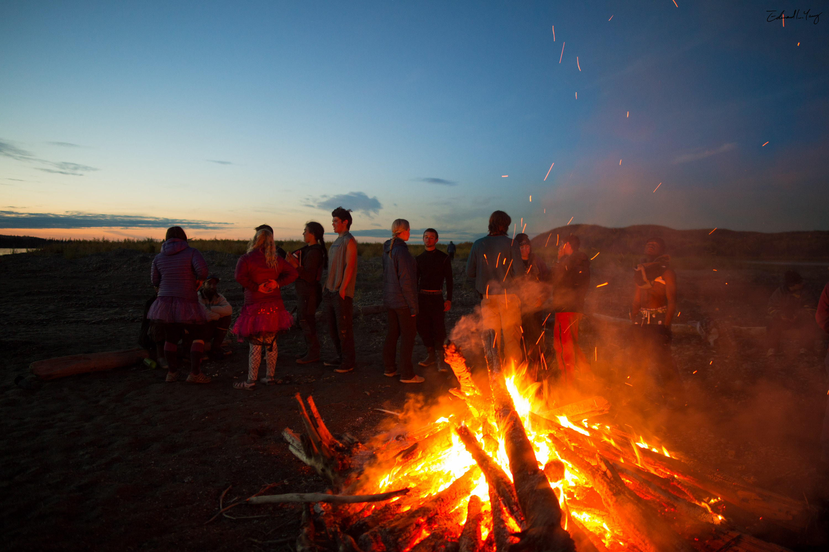
After finishing the Yukon at Circle, Alaska, all members of Expedition Alaska will spend a night in Fairbanks. OS11000 will reorganize for an 8-9 day backpacking trip in the Chugach Mountains.

This section explores the remote, scenic, and biologically rich Chugach Mountains east of Anchorage. We will be hiking 5-10 miles a day with packs weighing 50-60 pounds. The route has few if any trails and requires crossing high mountain passes, bushwacking, and crossing cold rivers.

That’s the challenge. The rewards are many: becoming a competent and strong outdoor traveller, experiencing seeing Dahl Sheep and other wildlife, and starting the process of becoming an outdoor professional.

Once the hiking section is completed the course returns to Anchorage to clean up, debrief, and celebrate an amazing experience.

What you can do to prepare . . .
- Get in shape: a moderate amount of daily aerobic exercise (eg: 1 hour of cardio vascular workout such as biking or running) is a minimum. Then add strength by hill or stair climbing. When I was in college I prepared for my summer camp work in Wyoming by putting my text books in a pack and running stairs in my dorms! Once a week go for a long, easy workout. This means 4-6 hour hike, walk, or bike ride that teaches your body and mind how to endure.

- Read the required text: this is provided for you by APU, Into the Wild, by John Krakauer. We’ll be discussing decision-making among other themes addressed in this book.

- Get psyched! Where we are going and what we are learning is something that few people, college students included, do.

